

Delivery Points
Architecture

Revision History
Date | Version | Description | Author
03/26/2014 | 1.0 | Created | Jim Heary

Table of Contents
Introduction 4
Overview 4
Scope 5
Risks 5
Business Activities 6
View Delivery Points 6
Export Delivery Points 6
System Analysis 7
Overview 7
Actors 7
Use Cases 8
View Delivery Points 8
Update Delivery Points 8
Export Delivery Points 8
Read Tsort Stores/Vendors 9
Read Roadshow Customers 9
Business Rules 9
Non-functional Requirements 9
Presentation 9
Performance 9
Security 9
Availability 9
Concurrency 9
Interoperability 9
Key Abstractions 10
States 10
System Design 11
Overview 11
Design Model 11
Structure 11
Behavior 12
User Interfaces 12
Persistence 12
Availability 13
Concurrency 13
Security 13
Deployment 13
Project Planning 15
Iteration 1 15
Appendix 15
Reports 15

Introduction

Overview
Stores and vendors are created and modified in the Tsort system via AS/400 green screens by an Argix Logistics Customer Service Representative. The delivery locations for these stores and vendors are then imported into the Roadshow system to be available for pickups and deliveries by the Argix local terminals. The AS/400 provides two feeds of delivery locations: the first includes all new store/vendor locations and is imported into Roadshow by the Ridgefield Dispatch Clerk prior to creating route solutions; the second includes new and updated store/vendor locations and is imported into Roadshow by the Argix Logistics Roadshow Specialist.

The Roadshow Specialist normally reviews, validates, and corrects the customer locations in the Roadshow system; but theses corrections are not updated to the AS/400. Therefore, future imports of delivery locations can overwrite the corrected customer locations in the Roadshow system. The Roadshow Specialist needs to review, validate, and correct delivery location updates prior to importing into the Roadshow system so as not to overwrite previous corrections.

This document details known requirements and a candidate design. It does not address manpower requirements or project scheduling, although these can be determined from this architecture.

How to read this document:
Management- Introduction, Analysis (Overview, Business Activities, Actors), Project Planning
Operations- Introduction, Analysis, Project Planning
IT- Introduction, Analysis, Design, Project Planning

Context
The following diagram provides context for the system under discussion. This is a high level view of the structure of the system; it helps us to understand the people, hardware, and systems that interact with our system.

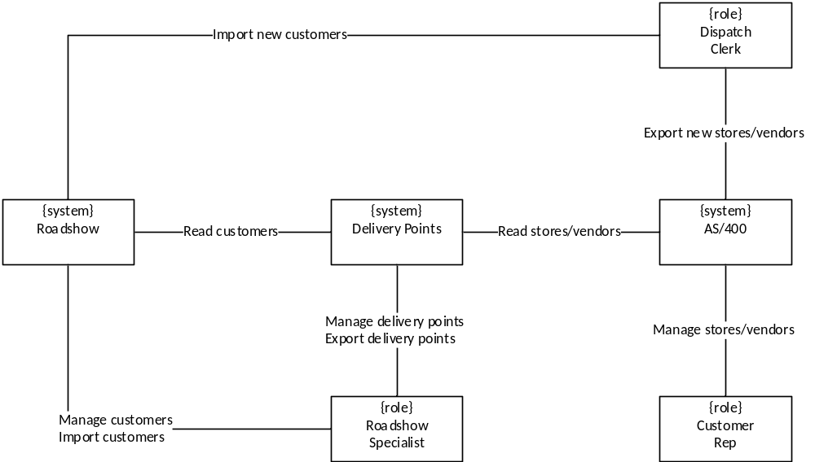

Scope
Solution Boundary
The solution will provide a means to review, validate, and correct delivery points from the AS/400 prior to import into the Roadshow system. It will not address interoperability between the AS/400 and Roadshow (i.e. updating AS/400 store/vendor addresses).

Constraints
- The solution shall conform to the principles of a Service Oriented Architectures (SOA).
- The solution will use the current Microsoft-based platform and Microsoft-based development tools.

Risks
- There are no risks to address at the current time.

Business Activities
The following diagrams show the business activities for the Delivery Points system. Business activities are modeled using activity diagrams. Activity diagrams show a series of activities, the actors responsible for each activity, and the information consumed and created during the process. These diagrams use the language of the business. Activity diagrams drive the discovery of Actors, Use Cases, and Key Abstractions.
View Delivery Points
The Roadshow Specialist chooses to view new and updated delivery locations from the AS/400 system. The resulting delivery points are annotated with the differences between the store/vendor location and the customer location in the Roadshow system concerning address and window information.

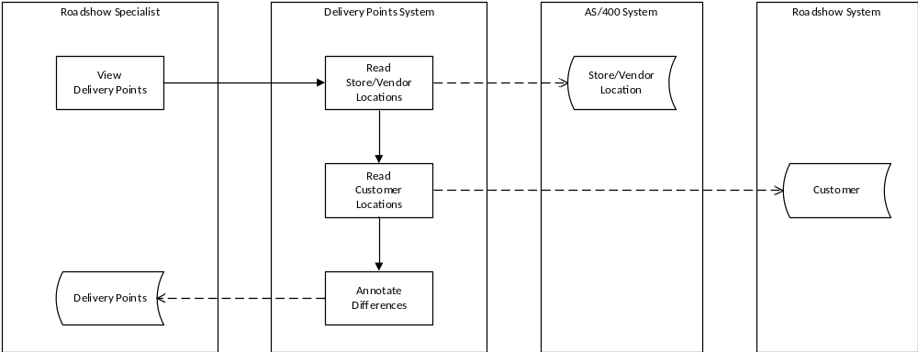

Export Delivery Points
The Roadshow Specialist chooses to export delivery points into the Roadshow system.

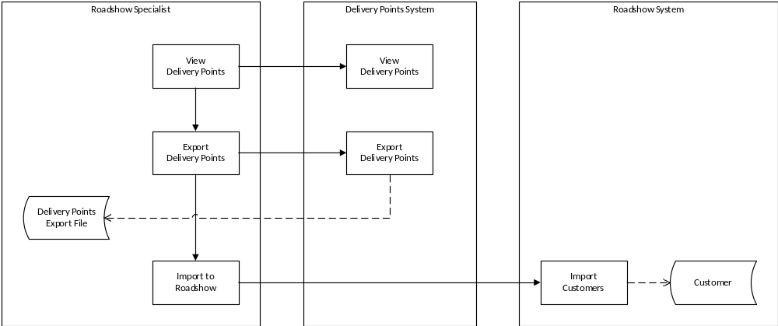

System Analysis

Overview
The purpose of defining system behavior is to discover, capture, and analyze the requirements of the system under discussion. This is achieved by describing the requirements (i.e. the conditions or capabilities to which the system must conform) well enough so that an agreement can be reached between the business users and the system developers on what the system should and should not do. It begins by modeling the business processes with a series of activity diagrams. These diagrams drive discovery of the users of the system (i.e. Actors), the system functionality (i.e. Use Cases), and the vocabulary of the system (i.e. Key Abstractions). From these artifacts, an analysis model is created that drives system design and development.

Actors
An actor specifies a role played by a user or any other system that interacts with the system under discussion. Actors influence UI design and security concerns. The list below provides definitions for the actors surrounding the Delivery Points system.
- Delivery Points- the system under discussion.
- Roadshow Speacialist
- Customer Rep-
- Dispatch Clerk-
- AS/400-
- Roadshow-

Use Cases
A Use Case is a list of steps, typically defining interactions between a role (i.e. Actor) and a system to achieve a goal. The actor can be a human or an external system. Use Cases describe the functional view of the system under discussion as a set of business transactions. Use Cases influence UI design, domain models, application service interfaces, and define business transactions. The following Use Case diagram shows some, if not all, of the actors and use cases involved in the system.

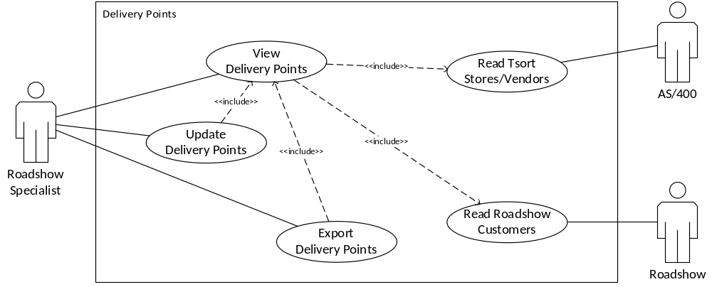

View Delivery Points
The Roadshow Specialist needs to…
Update Delivery Points
The Roadshow Specialist needs to…
Export Delivery Points
The Roadshow Specialist needs to...
Pre-Conditions:

Flow of Events:
Basic Path

Alternative Paths
The system does not have

Post-Conditions:

Read Tsort Stores/Vendors
The Delivery Points system needs to read new and updated store/vendor locations from the Tsort system in the AS/400. The following fields are required for each store or vendor: account, name, address, route, phone, open/close window times for Monday thru Sunday, stop name, stop phone, stop address, stop comment, stop open/close window times for Monday thru Sunday, and last updated time.
Read Roadshow Customers
The Delivery Points system needs to read all existing customer locations from the Roadshow system. The following fields are required for each customer: : customer id, account id, customer name, customer address, customer open/close window times for Monday thru Sunday, stop name, stop address, stop phone, and stop open/close window times for Monday thru Sunday.

Business Rules
- A customer window must be within the corresponding stop window.

Non-functional Requirements
Presentation
Rich client user interface with spreadsheet capabilities. No tablet or mobile at this point.
Performance
Unspecified.
Security
Authentication
Users will be authenticated by the Argix network domain.
Authorization
Role-based authorization (i.e. Roadshow Specialist) using domain accounts.
Availability
Normal business hours.
Concurrency
None required; this is a single user application with no backend persistence.
Interoperability
Roadshow- Roadshow services are exposed as SQL stored procedures.
Tsort- Tsort services are exposed as SQL stored procedures.

Key Abstractions
The class diagram below shows the key abstractions involved in the system. Key abstractions are the key concepts and abstractions that the system needs to handle. They are those things that, without which, you could not describe the system. Key abstractions drive design of the database schema and the domain model (if applicable).

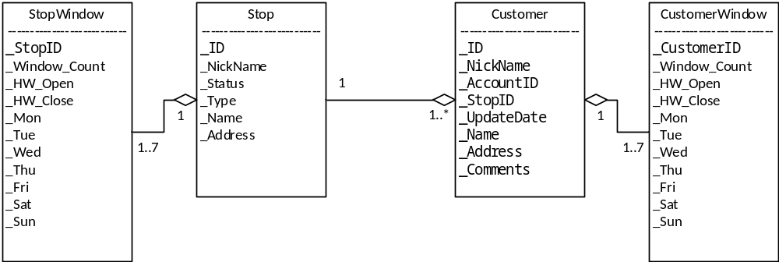

- Customer- .
- CustomerWindow- .
- Stop- .
- StopWindow- .

States
The state machine view describes the dynamic behavior of objects over time by modeling the lifecycles of objects of each class. Each object is treated as an isolated entity that communicates with the rest of the world by detecting events and responding to them. Events represent the kinds of changes that an object can detect. Anything that can affect an object can be characterized as an event.

Delivery Point
A Delivery Point is in a new state...

[State Machine Diagram]

System Design

Overview
The system design includes a rich Windows client that provides management of delivery points. It accesses back-end databases through web services arranged in a Service Oriented Architecture (SOA). Security is provided by an ASP.Net membership database hosting domain accounts. Program services are secured using pre-defined user roles.

Design Model
Structure
The design is an n-tier physical and logical design composed of a .NET 4.0 Win Forms client (DeliveryPoints.exe), several .NET 4.0 WCF Services (Argix10.Terminal.Services), and a SQL Server 2008 R2 database. The design as a whole is built to conform to a Service Oriented Architecture. Service Oriented Architectures describe ways to build loosely-coupled systems composed from individual services. All software components are built with Microsoft Visual Studio 2010 and compiled to operate in.Net 4.0 framework environments. The structures of the design are defined by drawings of the components and interfaces. The behaviors of the design are defined by sequence diagrams involving the interactions between the components.

Enterprise Patterns
In software engineering, a design pattern is a general reusable solution to a commonly occurring problem within a given context in software design. It is a description or template for how to solve a problem that can be used in many different situations. Patterns are formalized best practices that the programmer must implement in the application. Object-oriented design patterns typically show relationships and interactions between classes or objects, without specifying the final application classes or objects that are involved. The following enterprise design patterns are used in throughout the design:

Transaction Script- a Transaction Script organizes business logic by procedures where each procedure handles a single request from the presentation. They are an excellent choice when we don’t have a middle tier domain model. Transaction scripts are used in the web services to provide business transactions and security for one or more use cases.
Gateway- a Gateway is an object that encapsulates access to an external resource such as a web service or database server. Gateways are used throughout the design for user interface access to middle tier web services, for web service access to backend database services, and for web service access to external hardware including a label printer.
Record Set- a Record Set is an in-memory representation of tabular data; record sets (i.e. Dataset) work well with .NET user interface components.
Data Transfer Object- a Data Transfer Object (DTO) is an object that carries data between processes in order to reduce the number of method calls. Data Transfer Objects are serialized classes exposed by the interfaces of the web services for transactional calls to the middle tier (i.e. Service::Method(DTO dto)).

System Structure
The following drawing shows the components and interfaces (structure) of the Delivery Points design, and the connections between the various components. Components are denoted with tabbed containers. The rectangles within the components are software units stereotyped with their functional purpose such as a gateway or transaction script.

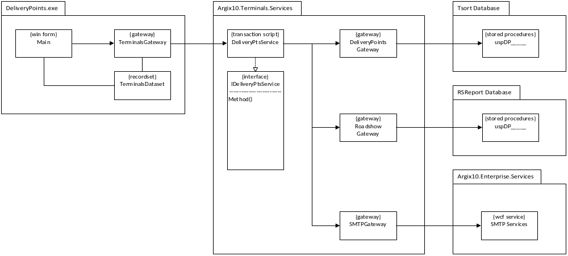

Behavior
System Behavior
The following drawing shows the behavior of …

[Design Behavior Drawing]

User Interfaces
Windows Client
The Delivery Points Windows application is built using .NET Win Forms for the .NET 4.0 Framework. It communicates with a middle-tier WCF service using the WcfHttpBinding binding. It is secured using an ASP.NET Membership services database through a WCF Role Service.

The application is built using Visual Studio 2010 and is deployed onto a LAN-based IIS 7.5 web server where it is installed onto client computers using the Click-Once technology.

Persistence
Database Schema
The database schema is initially derived from the Key Abstractions. The drawing below

The database is built and deployed with a SQL Server 2008 R2 database server. The schema is exposed through stored procedures.

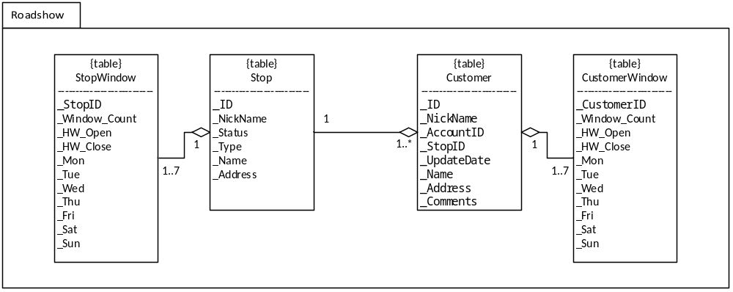

Availability
As dictated by the platform.

Concurrency
There are no entities that require concurrent access.

Security
Authentication
Windows network login.

Authorization
The windows application uses ASP.NET role-based security to authorize access to application features and services. The RoleServiceGateway encapsulates the details to access the RoleService from the MembershipServices web service. The RoleServiceGateway also acts as a policy file where role-based access is queried by user interface objects. The following drawing shows the processes and components that realize the application authorization design.

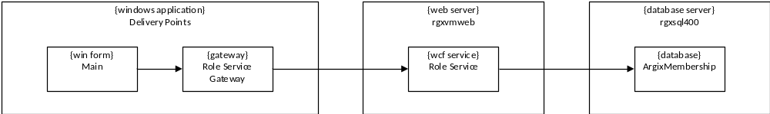

Deployment
The current deployment consists of a centralized application on the Jamesburg local area network (LAN) with client computers running on the Jamesburg LAN as well. Access to the application will be via the Argix Corporate Portal (i.e. SharePoint) using a Click-Once deployment that assumes the deployment server is always available; although the deployment is cached on the client, the server is always checked for a version update. Additional information concerning the click-once deployment can be found in the release notes accessible from the Help menu.

The deployment platform is as follows:
- Client- Windows7 operating system with .NET Framework 4.0 (full, not client)
- Web/Application Servers- Windows Server 2008 R2 and IIS 7.5 with .NET Framework 4.0
- Database Servers- Windows Server 2008 R2 and SQL Server 2008 R2
- Enterprise Service Bus- Windows Server 2008 R2 and BizTalk Server 2010
- Reporting Server- Windows Server 2008 R2 and SQL Server Reporting Services 2008 R2

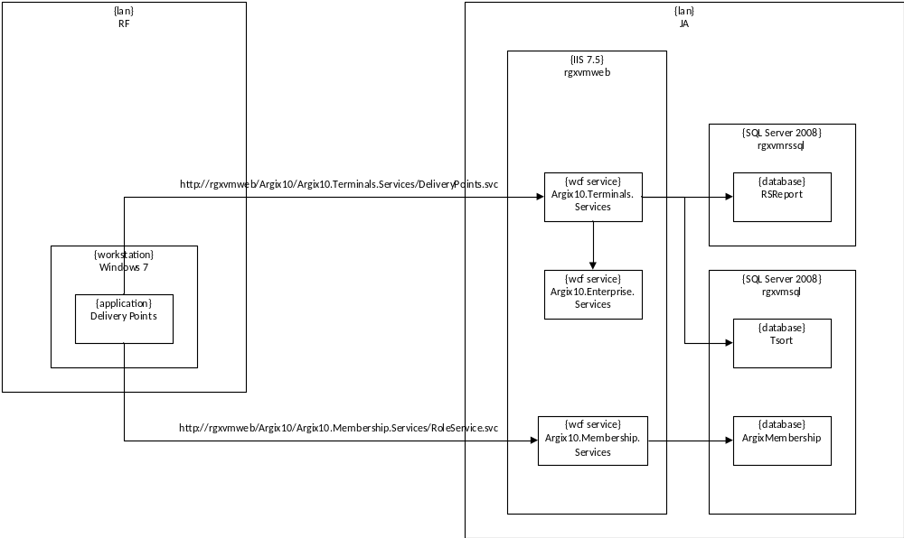

Project Planning

Iteration 1
Implement the following Use Cases:
Use Case 1
Use Case 2

Address the following risks:
Risk 1

Appendix

Reports
Report 1

[Report 1 Image]

